Protocol for responding to a reported safeguarding incident

Version 1: 18 July 2023

Safeguarding Incident Protocol

1. Introduction

Taith is an all-Wales programme funded by the Welsh Government, which awards funding to learning providers/external organisations in Wales to support participants (learners, young people and staff) to undertake international learning exchange activities both outward (from Wales to destinations abroad) and inward (from destinations abroad to Wales). Its delivery mechanism is via International Learning Exchange Partnership (ILEP) Ltd, a wholly owned subsidiary of Cardiff University.
As a part of the funding process, grant recipients (organisations who receive Taith funding for international learning exchanges) must confirm they have the following in place in relation to the participants and funded project activities:
- Safeguarding procedures (evidence required)
- Child protection policy (if working with under 18s)
- GDPR and information security compliance
- Appropriate insurance (evidence required)
This protocol should be used in the event of Taith being notified of a safeguarding incident or issue where Taith funded participants may be affected. If a reported incident relates to an incident overseas, the protocol should be followed in conjunction with the Significant International Incident protocol, where relevant.

For the purpose of this protocol a “safeguarding incident” is an incident or allegation of harm or risk of harm, whether intentional or unintentional, to an at risk/vulnerable adult or child.

All participants undertaking international mobilities are covered by the grant recipient organisations own safeguarding policies and procedures, as confirmed within the grant agreement and this should be made clear to participants, by the grant recipient organisation, before participation in activities.

Upon being notified of a safeguarding incident Taith may establish a safeguarding response group to guide ongoing risk assessment and response.

Taith’s Safeguarding Response Group will comprise of the following members:
- Executive Director
- Safeguarding Lead for ILEP Ltd Board of Directors
- Head of Policy, Programmes and Engagement (Lead Safeguarding Officer)
- Relevant Programme Manager
- Deputy Safeguarding Officer(s) (where this is not the relevant Programme Manager)

Other Taith Executive may be invited to attend as appropriate, including:
- Head of Operations
- Relevant Sector Project Officer(s)
- Communications and Marketing Officer
- Finance Manager
Protocol for dealing with safeguarding incident reports
2. Overview of Taith Response

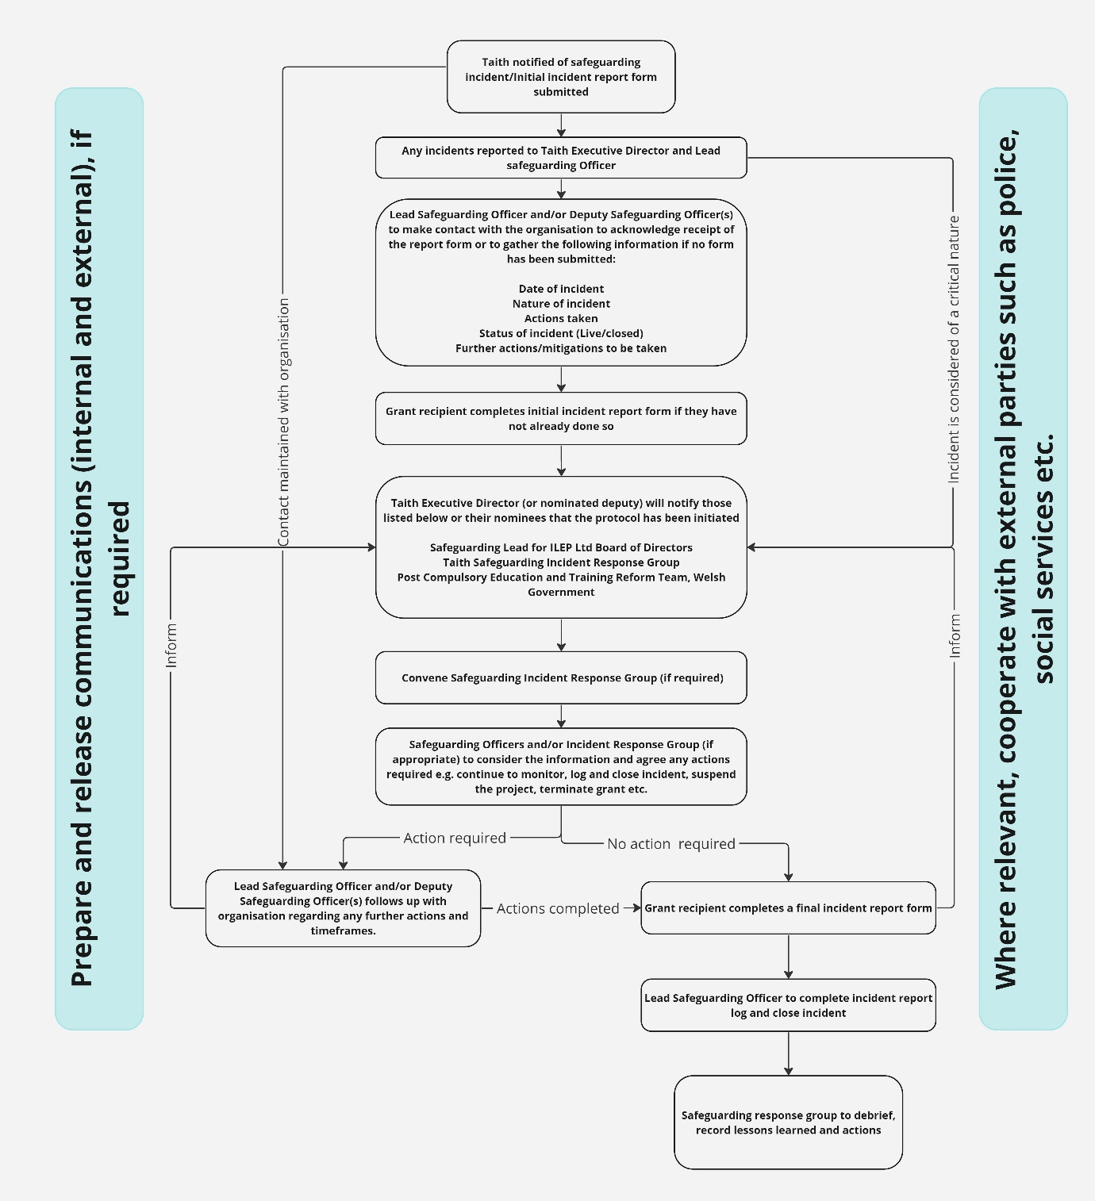

3. Basic Principles

The basic principles in responding to a report of a safeguarding incident are as follows:
- Taith will seek confirmation that grant recipients have appropriate safeguarding policies and procedures in place prior to any funded activity taking place.

- The grant recipient has direct duty of care for participants as outlined in the grant agreement.

- The grant recipient has responsibility to ensure all international partners have appropriate policies and procedures in place, relating to the participants.

- Where a grant recipient is a consortium lead, they have responsibility for ensuring their consortium partners have appropriate policies and procedures in place, relating to the participants.

- All grant recipients have a whistleblowing procedure in place which should encourage staff, participants and/or other concerned parties to share any safeguarding concerns. The procedure should set out a fair and safe process to deal with such concerns. In the instance that a person does not feel they can raise a concern directly with a grant recipient, they can raise concerns with Taith through our Whistleblowing procedure.

- Taith will seek to respond in a timely manner, convening such decision-making groups as appropriate within the normal confines of the workday in the UK and mindful of time differences across the globe.

- Taith will seek to respond in an informed manner. Our response should be informed by the best information available at the time. We will follow advice from relevant authorities, where appropriate.
- Taith will take steps to record our response and learn from it. All action taken should be documented in detail for future reference using risk assessment and other established Taith processes as appropriate.
- The law and relevant Taith policy must be observed at all times, including safeguarding and the Data Protection Policy.

- Taith will, where required, cooperate with any relevant authorities in Wales and overseas e.g. police, social services etc.

- Taith safeguarding falls under Cardiff University’s safeguarding policy as per, the service level agreement. However, Cardiff University’s policy is directly related to incidents involving staff and/or students which do not come under the responsibility of Taith. As a result, Taith has developed this policy to outline the protocol Taith will use in the event of a Safeguarding incident. Taith will report incidents to the University (see 6.6).

4. Legal Issues

4.1 Data Protection and Confidentiality

The processing and sharing of participants or grant recipient organisation contacts personal data is subject to the terms and conditions of the Data Protection Act 1998. This means that there is a clear expectation that a participant or a grant recipient organisation contacts’ personal details are not made public or shared inappropriately.

However, there may be times when it is legitimate for Taith to act in a participant or grant recipient organisations’ best interests and share this personal data. If there is genuine concern for a participant’s welfare then information which is pertinent to the situation should be shared between relevant Taith and related parties (for example, the Welsh Government, police, social services etc.).

It is the duty of the grant recipient organisation to respond to enquiries from concerned friends or family members of participants and any enquiries of this nature will be passed to the grant recipient organisation,

Taith’s full Privacy Policy can be found through the links below:

- Taith Privacy Policy

- Taith confidentiality Policy

The full Data Protection Act 1998 can be found at:

https://ico.org.uk/for-organisations/guide-to-data-protection/

Taith will treat all safeguarding incident reports as confidential and will limit information to those who need to be informed. When collecting information on the incident, Taith will require personal details of participants or those involved in incidents.

5. Notification

There are a number of ways in which Taith may be notified or become aware of a safeguarding incident which may lead to a requirement to respond under this protocol, this might include:

- An alert from a grant recipient organisation (this may include the submission of an initial incident report form or may be via phone or email etc.).
- A separate organisation contacts Taith directly to raise a concern.
- A participant or family member/friend contacts Taith directly to raise a concern.
- Media coverage

If a member of staff becomes aware of a safeguarding incident, they should alert the Taith Executive Director and Lead Safeguarding Officer who will inform the Safeguarding Lead of ILEP Ltd Board, the Deputy Safeguarding Officers, the Taith Senior Leadership team and, the Post Compulsory Education and Training Reform Team, Welsh Government, if appropriate.

If a participant or grant recipient organisation contacts Taith to report a safeguarding incident, we will follow the process detailed below.

6. Taith response protocol

6.1 Communication

Upon being informed of a safeguarding incident, the Taith Executive Director (or nominated deputy) will notify those listed below or their nominees that the protocol has been initiated:

- Safeguarding Lead of ILEP Ltd Board
- Taith Safeguarding Incident Response Group (if appropriate)
- Post Compulsory Education and Training Reform Team, the Welsh Government.

6.2 Establishment of Safeguarding Incident Response Group

If it is considered appropriate, the Safeguarding Incident Response Group will be set up. The Safeguarding incident response group will comprise of the following members:
- Executive Director
- Safeguarding Lead for ILEP Ltd Board of Directors
- Head of Policy, Programmes and Engagement (Lead Safeguarding Officer)
- Relevant Programme Manager
- Deputy Safeguarding Officer(s) (where this is not the relevant Programme Manager)

Other Taith Executive may be invited to attend as appropriate, including:
- Head of Operations
- Relevant Sector Project Officer(s)
- Communications and Marketing Officer
- Finance Manager
- Cardiff University Academic registrar (where Cardiff University may be impacted as a result of the incident)

6.3 Gathering information

The Lead Safeguarding Officer and/or Deputy Safeguarding Officer(s) will make contact with the organisation to acknowledge receipt of an initial incident report form or, if not report form has been submitted to gather the following information:

- Date of incident
- Nature of incident
- Actions taken
- Status of incident (Live/closed)
- Further actions/mitigations to be taken

The organisation will be asked to complete an initial safeguarding incident report form (if they have not already done so) to provide further detail, followed by a full report once the incident is closed.

If appropriate, the Lead Safeguarding Officer and/or Deputy Safeguarding Officer(s) will report the information gathered to the Safeguarding Incident Response Group, who will consider what, if any, actions are required. This may include but is not limited to:

- Log and close the incident.
- Requesting further information.
- Continue to monitor the incident until it is satisfactorily closed.
- Suspend the project whilst further information is sought i.e., instruct the organisation not to carry out any further activity/mobilities whilst the incident is handled.
- Terminate the grant and request any underspend/claw back the whole grant.
- Refer the matter to the authorities (police, social services etc.).

6.4 Ongoing contact/support

Where actions are required/the incident is still live, the Taith Lead Safeguarding Officer and/or Deputy Safeguarding Officer(s) will maintain regular contact to ensure action is taken and the incident is satisfactorily closed.

6.5 Incident closure

At the point of incident closure, the Lead Safeguarding Officer and/or Deputy Safeguarding Officer(s) will complete the safeguarding incident log and file all relevant documentation including the safeguarding incident report.

The Safeguarding Incident Response Group will consider any lessons learned from the incident and will review and update any relevant policies and procedures and set out any further actions to be taken.

6.6 Reporting of safeguarding incidents

The following require information regarding safeguarding incidents:
- ILEP Ltd Board
- Welsh Government
- Cardiff University

Information will be provided in the form of an assurance statement. The following information will be included in the Assurance statement:
- Number of safeguarding incidents reported.
- Status of incidents.
- Notable actions (e.g. reported to authority/termination of grant)

Taith will provide the assurance statement to the ILEP Ltd Board of Directors and the Welsh Government quarterly and annually to Cardiff University).

7. Communication
7.1 Internal communications

Taith has set out within the protocol, who will be informed of the incident and updated. It is acknowledged that the funder the Welsh Government, may also be required to communicate internally such as informing the Minister of the incident.

Taith will adhere to its confidentiality policy as well as Data Protection legislation and information will only be passed on where required and/or deemed relevant and necessary.

7.2 Communicating with those involved

- Taith will liaise with the grant recipient organisation directly but does not anticipate communicating with participants or other affected parties.
- Where an incident has been reported by a party other than the grant recipient organisation, Taith will not give any information or updates unless considered essential and relevant. The reporter will be thanked for bringing the issue to Taith’s attention and informed that Taith will respond according to internal protocol.

7.3 External communications

The Communications and Marketing Officer will:

- Contribute to any incident response group meeting, where relevant.
- Manage media enquiries into the incident and its effect on Taith.
- Determine whether, and by what means, Taith should make a statement regarding the incident. This may be, for example, an internal message to Taith staff or a public statement released via official social media accounts or on the Taith website.

In the instance of serious or complex situations likely to affect Taith or Cardiff University’s reputation, the Communications and Marketing Officer will be supported by the Cardiff University Communications Team.

In the instance of serious or complex situations likely to affect Taith or the Welsh Government’s reputation, the Communications and Marketing Officer will be supported by the Welsh Government Communications Team.

8. Debriefing and Revision

Every safeguarding incident is different. With each incident comes new experiences and lessons. Therefore, it is important that processes are reviewed.

For each incident, the Lead Safeguarding Officer and Deputy Safeguarding Officers will consider any lessons learned and implement changes where identified.

Where relevant, the Taith Safeguarding Incident Response group will hold a debrief meeting to include reviewing the process and taking on board any feedback from those involved, both internally and externally.

Should any incidents be reported, staff involved may be debriefed afterwards, whatever the outcome of the incident. During this debriefing session staff will be offered support, as well as being encouraged to share their experiences and discuss whether anything can be changed or added to the protocol to make it more effective.

