**Responding to a significant international incident protocol**

Version 3: February 2024

**Significant International Incident Protocol**

**1.** **Introduction**

Taith is an all-Wales programme funded by the Welsh Government, which awards funding to learning providers/external organisations in Wales to support participants (learners, young people and staff) to undertake international learning exchange activities both outward (from Wales to destinations abroad) and inward (from destinations abroad to Wales). Its delivery mechanism is via International Learning Exchange Programme (ILEP) Ltd, a wholly owned subsidiary of Cardiff University.

As a part of the funding process, grant recipients (organisations who receive Taith funding for international learning exchanges) must confirm they have the following in place in relation to the participants and funded project activities:

* Safeguarding procedures (evidence required)
* Child protection policy (if working with under 18s)
* GDPR and information security compliance
* Appropriate insurance (evidence required)

This protocol should be used in the event of a significant incident occurring overseas for outward mobilities or, in Wales for inward mobilities and where Taith funded participants may be affected*.

For the purpose of this protocol a “significant international incident” could be an event which affects one or more participants on any type of Taith funded mobility (both inward and/or outward). It might be an event of international significance (e.g. a terrorist attack or natural disaster) in a location where one or more participants are nearby; or it may be a specific event affecting one or more participants which does not have international significance but does create a complex set of issues for Taith (e.g. a road traffic accident).

There may be instances where an incident occurs that has the potential to become or could have been but did not develop into a significant international incident. These incidents are referred to as notable incidents (Annex 2).

All participants undertaking international mobilities are covered by the grant recipient own insurance (including public and employer liability and travel insurance), as confirmed within the grant agreement and this should be made clear to participants, by the grant recipient, before departure.

[Foreign, Commonwealth and Development Office](https://www.gov.uk/foreign-travel-advice) (FCDO) foreign travel advice will be followed throughout any changing situation.

If at any point during the implementation of this protocol, the situation is deemed to be deteriorating or risks to personal safety change, Taith’s International Incident Response Group should be established as quickly as possible to monitor the ongoing situation and response.

Taith’s International Incident Response Group will comprise;

* International incident lead on ILEP Ltd Board
* Executive Director (Chair)
* Head of Policy, Programmes and Engagement
* Head of Operations
* Senior Communications and Impact Officer

Other Taith Executive may be invited to attend as appropriate, including:

* Sector Programme Manager(s)
* Sector Project Officer(s)
* Grants Officer(s)
* Grants Assistant(s)

*Taith staff are employed by Cardiff University. Taith staff undertake international travel as a part of their role. In the instance that a member of staff is affected by a significant international incident, Cardiff University will implement their Significant International Incident Protocol to respond to the incident and support the member of staff.

**Protocol for dealing with significant international incidents**

**2.** **Overview of Taith Response**

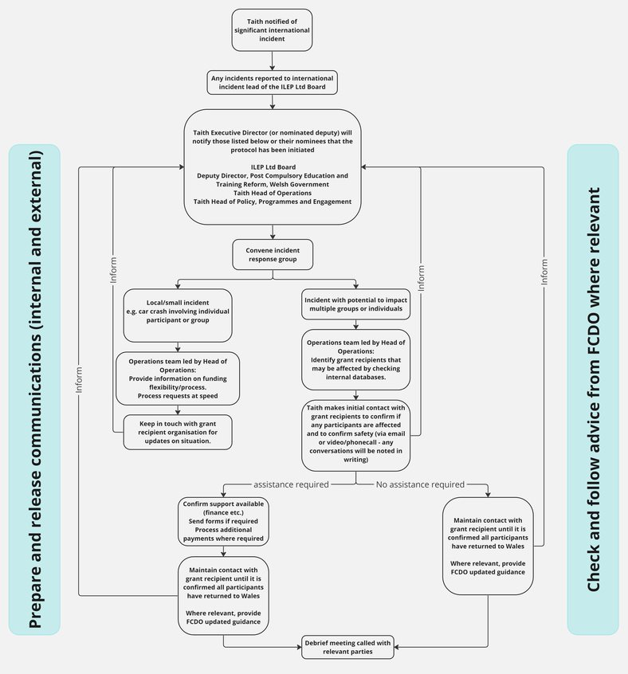

**3. Basic Principles**

The basic principles in responding to a significant incident overseas are as follows:

* The grant recipient has direct duty of care for participants as outlined in the grant agreement.
* Taith will seek to respond in a timely manner, convening such decision-making groups as appropriate within the normal confines of the workday in the UK and mindful of time differences across the globe.
* Taith will seek to respond in an informed manner. Our response should be informed by the best information available at the time. We will follow advice from relevant authorities in country, and by travel advisory guidance from the FCDO where appropriate.
* It is the duty of the grant recipient to keep next of kin informed within the bounds of the Data Protection Act.
* Taith will take steps to record our response and learn from it. All action taken should be documented in detail for future reference using established Taith processes as appropriate.
* The law and relevant Taith policy must be observed at all times, including safeguarding and the Data Protection Policy.

**4. Legal Issues**

**4.1 Data Protection and Confidentiality**

The processing and sharing of participants or grant recipient contacts personal data is subject to the terms and conditions of the Data Protection Act 1998. This means that there is a clear expectation that a participant or grant recipient contacts personal details are not made public or shared inappropriately.

However, there may be times when it is legitimate for Taith to act in a participant or grant recipients’ best interests and share this personal data. If there is genuine concern for a participant’s welfare then information which is pertinent to the situation should be shared between relevant Taith and related parties (for example, the Welsh Government).

It is the duty of the grant recipient to respond to enquiries from concerned friends or family members of participants and any enquiries of this nature will be passed to the grant recipient.

Taith’s full Privacy Policy can be found through the links below:

* [Taith Privacy Policy](https://www.taith.wales/privacy-policy/)

The full Data Protection Act 1998 can be found at:

<https://ico.org.uk/for-organisations/guide-to-data-protection/>

**5. Notification**

There are a number of ways in which Taith may be notified or become aware of an event overseas which may lead to a requirement to respond under this protocol, this might include:

* Media coverage
* An alert from a grant recipient
* A participant or family member/friend contacts Taith directly to raise a concern

If a member of staff becomes aware of a significant event overseas which may affect participants, they should alert the Taith Executive Director who will inform the international incident lead of the ILEP Ltd Board and the Deputy Director, Post Compulsory Education and Training Reform, the Welsh Government, if appropriate.

If Taith is notified of a significant incident, we will follow the process detailed below.

**6. Taith response protocol**

When informed of a significant incident, the Taith Executive Director (or nominated deputy), through discussion with the international incident lead of the ILEP Ltd Board (or nominated deputy), will instigate this protocol, in proportion to the nature, scale and impact of the incident.

Relevant contact details are included in Annex 1.

**6.1 Communication**

Section 7 details the communication protocol for a significant international incident.

**6.2 Establishment of International Incident Response Group**

Taith’s International Incident Response Group will comprise;

* International incident lead on ILEP Ltd Board
* Executive Director (Chair)
* Head of Policy, Programmes and Engagement
* Head of Operations
* Senior Communications and Impact Officer

Other Taith Executive may be invited to attend as appropriate, including:

* Sector Programme Manager(s)
* Sector Project Officer(s)
* Grants Officer(s)
* Grants Assistant(s)

**6.3 Identifying affected grant recipients and participants**

The Taith Head of Operations (or nominated deputy) will identify grant recipients that may have participants in the affected area by:

* Checking local databases; specifically, the Taith grant recipient directory, [pathway outcomes spreadsheets](https://cf.sharepoint.com/:f:/r/teams/ILEPActionandOperationalPlans/Shared%20Documents/Outcomes%20and%20Information%20Requests?csf=1&web=1&e=KVd7dC), most up to date [monthly participant data](https://cf.sharepoint.com/:f:/r/teams/ILEPActionandOperationalPlans/Shared%20Documents/Monthly%20participant%20reports?csf=1&web=1&e=iZvEUO) and project folders.
* Obtaining a list of grant recipients in affected areas from the Finance and Grants Team.

The Taith Head of Operations and Taith Head of Policy, Programmes and Engagement (or nominated deputy) will:

* If appropriate, draft an email to be sent to all grant recipients providing the latest FCDO advice, ask grant recipients to confirm if any participants are affected and to confirm safety, and request they respond to any requests for information quickly.
* Ask their teams to make further contact via email and/or phone, with grant recipients to confirm if any participants are affected and to confirm safety.

* Inform the Post Compulsory Education and Training Reform team in the Welsh Government of actions taken and provide a list of grant recipient who have been contacted.

**6.4 Protocol if making contact is unsuccessful**

If no response is received within the desired timeframe, the Taith Head of Operations and Taith Head of Policy, Programmes and Engagement (or nominated deputies) will contact grant recipient in the following ways:

* Call lead contact and all named contacts
* Contact the legal signatory
* Contact consortium partners where appropriate
* Contact local authority, where appropriate
  1. **Further actions**

1. **If all participants are reported as being safe and well,** Taith will draft an email to disseminate to grant recipients including information on:

* Any updated relevant FCDO guidance
* Support provided by Taith
* Any relevant Welsh Government guidance/support

Taith will ensure that relevant information is shared appropriately with the ILEP Ltd Board and with the Welsh Government to ensure appropriate awareness.

1. If any incidents involving participants/grant recipients are reported, Taith Executive Director (or nominated deputy) will be informed, and an Incident Response Group will be convened if required.

**6.6 Support**

It is the direct responsibility of the grant recipient to manage the situation in its entirety including supporting participants to return to their country of residency.

Where guidance from the FCDO advise against travel to a country or region it will be the responsibility of the grant recipient to assist in that evacuation in the most expeditious way possible.

In such instance, Taith will implement policy relating to Force Majeure as set out in the grant recipients grant agreement. This includes;

* Where this means the mobility will not meet the minimum duration requirements, Taith will waive the minimum duration and honour grant funding for the days the participant spent on the mobility.
* If additional exceptional costs are incurred due to the incident and these are not covered through insurance, Taith will consider these on a case-by-case basis.

Where an individual or group wish to leave an overseas location, but that desire does not correlate with FCDO guidance, Taith would consider any change request submitted. However, Taith would usually expect it to be the grant recipient’s responsibility to make their participants travel arrangements and incur the related costs.

Where participants are overseas and an incident prevents them from returning home, for example, travel is halted or borders shut, and/or where participants are undertaking inward mobilities and are unable to return to their home country, if additional exceptional costs are incurred due to the incident and these are not covered through insurance or other funding sources such as, grants specifically responding to the incident, Taith will consider these on a case-by-case basis, in consultation with ILEP Ltd and the Welsh Government. Requests should clearly demonstrate all other avenues of funding that have been utilised/exhausted prior to the request. In such instances, we would expect participants to leave the country at the earliest possible opportunity.

**7. Communication  
  
7.1 Notifications**

When informed of a significant incident, the Taith Executive Director (or nominated deputy) will notify the following people or their nominees that the protocol has been initiated:

* Remaining members of ILEP Ltd Board
* Deputy Director, Post Compulsory Education and Training Reform, the Welsh Government
* Taith Head of Operations
* Taith Head of Policy, Programmes and Engagement

The Taith Executive Director (or nominated deputy) will maintain contact with the above people throughout the process and until the matter is closed and lessons learned have been discussed and actioned.

**External communications**

The Senior Communications and Impact Officer will:

* Contribute to any incident response group meeting.
* Manage media enquiries into the significant overseas incident and its effect on Taith.
* Determine whether, and by what means, Taith should make a statement regarding the incident. This may be, for example, an internal message to Taith staff or a public statement released via official social media accounts or on the Taith website.

In the instance of serious or complex situations likely to affect Taith or Cardiff University’s reputation, the Senior Communications and Impact Officer will be supported by the Cardiff University Communications Team.

In the instance of serious or complex situations likely to affect Taith or the Welsh Government’s reputation, the Senior Communications and Impact Officer will be supported by the Welsh Government Communications Team.

**8. Debriefing and Revision**

Every overseas incident is different. With each incident comes new experiences and lessons. Therefore, it is important that processes are reviewed.

Where relevant, the incident response group will hold a debrief meeting to include reviewing the process and taking on board any feedback from grant recipients and Taith staff involved.

Should any incidents be reported staff involved may be debriefed afterwards, whatever the outcome of the incident. During this debriefing session staff will be offered support, as well as being encouraged to share their experiences and discuss whether anything can be changed or added to the protocol to make it more effective.

Annex 2: Notable incidents

There may be instances where an incident occurs that has the potential to become or could have been but did not develop into a significant international incident. These incidents are referred to as notable incidents. An example of a notable incident could be where a participant develops an illness whilst overseas or shortly after returning that might be contagious. If it is confirmed that it is contagious and has an impact on other participants, future mobilities such as participants needing to isolate or mobilities changing their destination, this would be considered a significant international incident and would follow the protocol above. If it was not found to have an impact on any other participants/mobilities and was not of concern, this would be a notable incident and would be recorded as such, through the Grant Recipient completing a notable incident form.