Pathway 2 (2025) budget example
When completing your Pathway 2 grant calculator, it’s important to clearly explain each cost in your application form. Any costs included in the calculator but not justified in the application form will be removed during assessment.
To help guide you, here’s an example answer to the questions in the budget section. This shows the level of detail we’re looking for, and how to link your requested costs to your project’s aims. A strong cost justification helps assessors understand why each item is essential to delivering your project and creating the planned output.
Questions
1. Please provide an explanation for the funding you have requested in the grant calculator for mobilities. Please also provide a brief overview of the activities you plan to undertake during each mobility.
You must provide details of each staff member and learner who will be taking part in the mobilities (outward and inward) Please explain each participant’s role during the mobility and why their participation is essential to the development of the project and the output.
Please ensure that every participant in both the ‘Staff Mobilities’ and ‘Learner Group Mobilities’ (inward and outward) tabs is accompanied by an explanation in the application form outlining their role and specific contribution during the mobility.
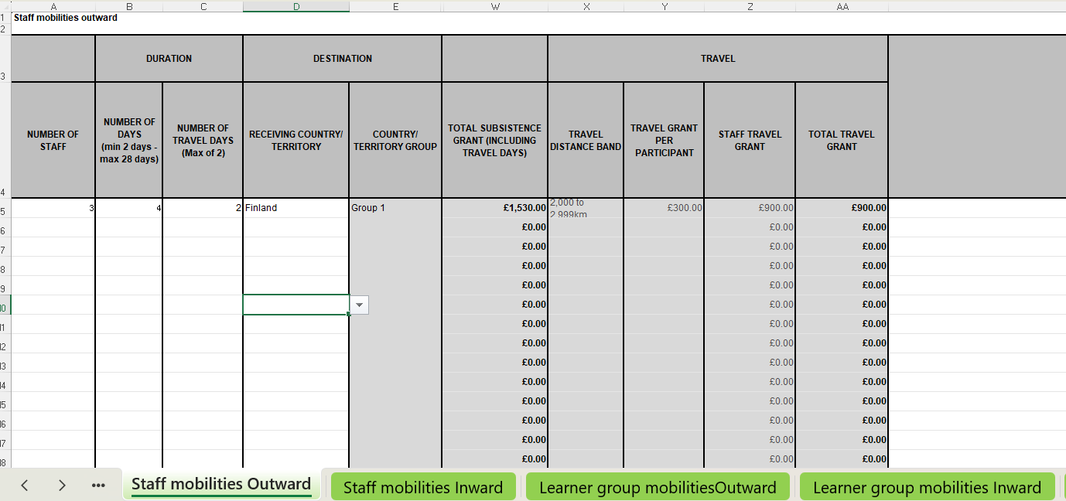

Example answer
Participant 1 - Headteacher
Their knowledge and extensive teaching experience are integral to the creation of the project output. The Headteacher will lead the meetings during the mobility to Finland together with the Headteacher from our international partner school.
Participant 2 - Teacher and Project Lead
As Project Lead, this teacher will coordinate all project activities, particularly during the mobility to Finland, to ensure that objectives and timelines remain on track. With expertise in supporting pupils with Additional Learning Needs, they will ensure that inclusivity is a central focus of the project and its implementation.
Participant 3 - Teacher
As well as teaching experience this participant’s focus within the school is to support pupils from underrepresented groups. They will exchange best practice with our international partner and contribute to the development of inclusive practices to be included in the final project output.
Planned Activities
- Day 1: Visits to three schools to observe and evaluate best practices.
- Day 2: Professional development sessions led by our international partner.
- Day 3: Collaborative workshops with the international partner to co-create project materials.
- Day 4: Joint development of practical resources to be disseminated after the mobility.

2. Please provide an explanation for the funding you have requested in the grant calculator within each category:

Staff Costs
Staff costs’ is a contribution to the staffing costs required to enable the project to take place. This section is for costs for staff from your organisation and partners (Welsh and International) only. Any external consultant costs should be included in the Project Management and Implementation section.
For every staff member listed in the ‘Staff Costs Wales’ and ‘Staff Costs International’ tabs of the grant calculator, please provide:
- An explanation of their specific role within the project
- A clear description of their contribution to the project's objectives
- Any relevant expertise or responsibilities that justify their involvement in the project

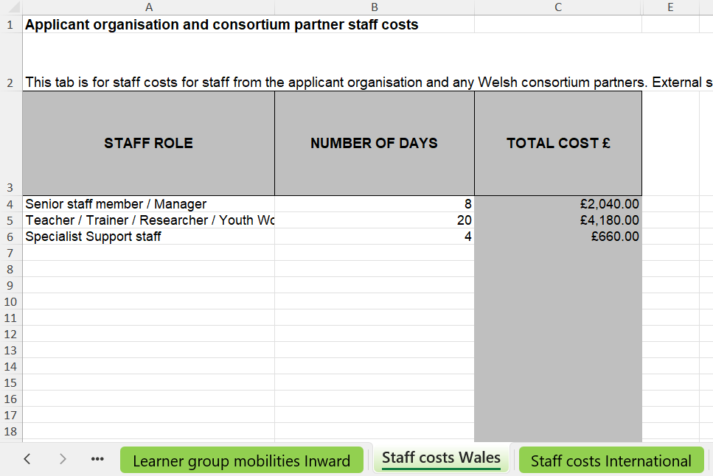.

Example answer
1. Headteacher (senior staff member/manager) - 8 days
The Headteacher will ensure that the project aligns with the sector priorities and Curriculum for Wales. They will oversee the project and creation of the output, manage relationships with project partners for the duration of the project, and contribute to dissemination activities by engaging sector leaders and stakeholders to ensure the long term impact of the project.
2. 2 x Teachers (Teacher/ Trainer/ Researcher/ Youth Worker) - 10 days each
Both teachers will use their teaching expertise and knowledge gained from the mobilities to co-develop resources for the toolkit. They will also deliver training workshops during the dissemination phase to train other teachers in using and applying the toolkit.
3. Finance Manager (Specialist support staff) - 4 days
They will ensure efficient financial management of the project, overseeing budgets and expenditure to ensure accuracy and transparency. They will be responsible for managing project budgets and tracking all financial activities.

Project Management and Implementation
‘Project Management and Implementation costs’ is a contribution to costs to enable the project and dissemination activities to take place.
Please ensure that each cost entered in the ‘PM&I Wales’ and ‘PM&I International’ tabs of the grant calculator is accompanied by a clear justification. Your explanations should demonstrate why each expense is necessary to successfully deliver and disseminate the project and create the output.
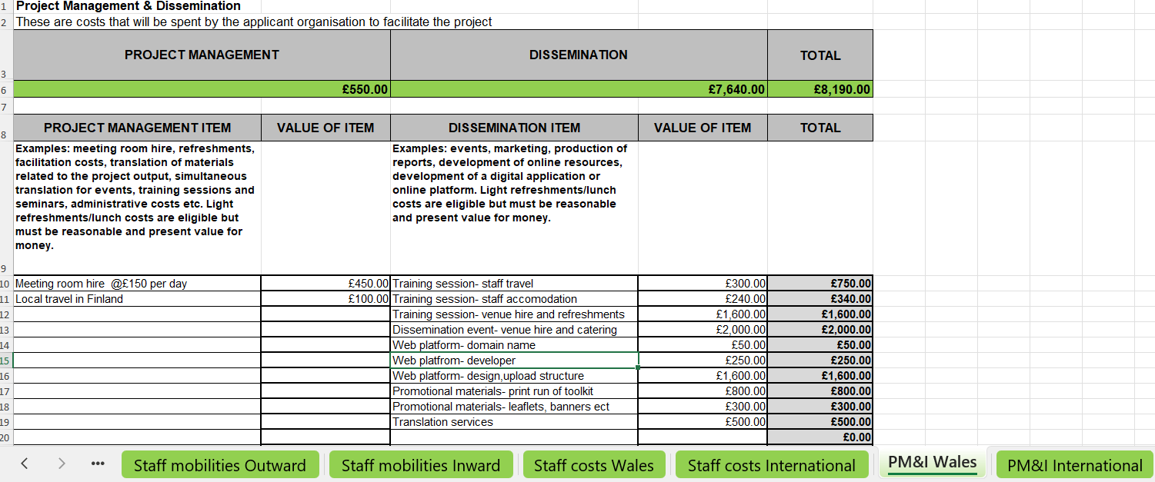

Example answer
Project management
1. Meeting room hire (during the mobility)
£150 per day x 3 days
A centrally located venue will be hired for the meetings with our international partners during the mobilities. Our host partner does not have the capacity or facilities to host the meetings. The venue was selected for value for money after reviewing quotes from several suitable venues.
2. Local travel during the mobility
£100
Local travel for visits to partner schools to observe best practice and gather ideas for the project output.
Dissemination
1. 4 regional training sessions (South, Mid, West, and North Wales) - £2140
We intend to hold 4 training sessions across Wales to support schools and organisations to engage with the toolkit.
Costs include:
- Travel for two staff members to and from each session- £300
- Accommodation for two staff members (North Wales session) £240
- Venue and equipment hire and refreshments for each session. 20 attendees per session-£1600

2. Dissemination event - £2000
To showcase the toolkit and share key findings with stakeholders. Approx 100 attendees.
Costs include:
- Venue hire (including technical equipment)
- Catering for attendees.
3. Toolkit web platform - £1,900
Breakdown:
- Domain name: £50
- Web developer (setup & hosting): £250
- Web developer (design, upload, structure): £1,600
The platform will ensure that all schools in Wales will have access to the toolkit.

4. Print and promotional materials - £1,100
Breakdown:
- Limited Print Run of Toolkit: £800
- Printed Promotional Leaflets / Display Materials / Banner: £300
Used for dissemination events and stakeholder engagement.

5. Translation Services - £500
To ensure inclusivity and accessibility, all materials will be provided bilingually in Welsh and English

